Logan Hoots, Lucio Infante, Karan Sharma

CST - 461 - WF700A

Professor Isac Artzi

Smart Contracts

1. Description of Challenge

The main challenge that is presented when working in a supply chain is making sure there is good communication between all participants in the chain. Whether it be knowing how much product is needed or tracking where the product may be in the supply chain. The challenge is to create functions that will give as much detail as possible. Keeping track of everything being passed on through the supply chain, such as product and ownership is something that is challenging in a supply chain.

1. Description of Solution

Being as detailed as possible could help have better communication between everyone in the supply chain. In the program we added a couple functions that would help in that area. We added constructors for trucks and retailers, which are participants in the supply, which gave details in both of them which we can use in the supply chain. Through the truck constructor we were able to create a newShipment function, which created a shipment that included information on the quantity of product, what products, the location, and ETA. We added a newStore function that allows us to have somewhere where the product will end up in the supply chain including the storename and the location. We included an addStock function in which we can add products into the retailers inventory.

1. Why Blockchain and this DApp is a Good Solution

The encrypted and decentralized nature of blockchain and DApp allows the user to keep a record (ledger) of all transactions made in the business. This also allows the user to create a system where all transactions are approved, monitored and approved by him and no one else making it clear that no one else can tamper with the leger and update it.

The supply chain system currently in use doesn't involve all parties involved in the transaction to see all relevant flows of information, inventory and money. This causes execution errors such as mistakes in inventory data, missing shipments and duplicate payments very difficult to detect. Fortunately, since the advent of blockchain all ends of the supply chain have been able to get involved in every process of the products manufacture and shipping.

Our DApp is a good solution to this problem because it accounts for flow of information to every party involved. It essentially is a master script that handles the backend of each system.

1. Complete Smart Contract

The smart track has been attached.

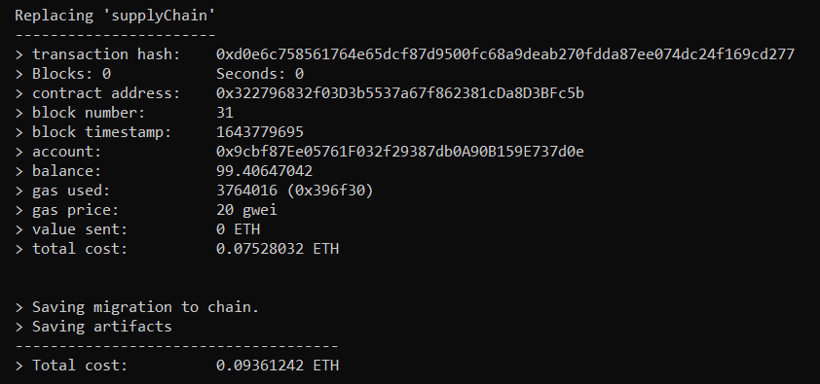

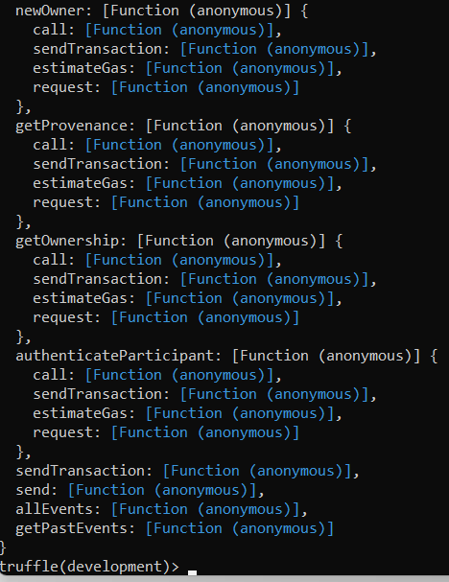

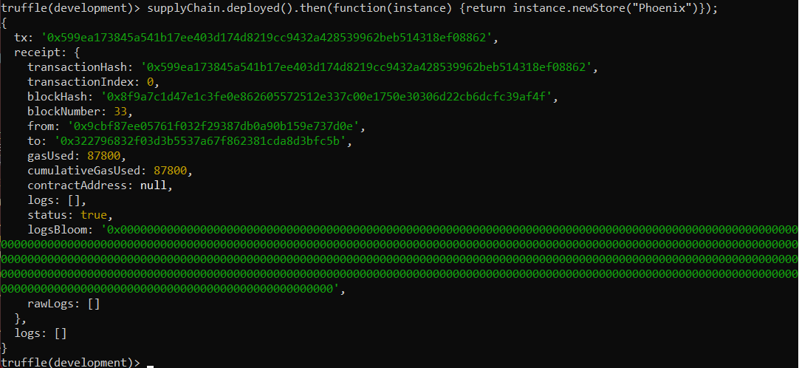

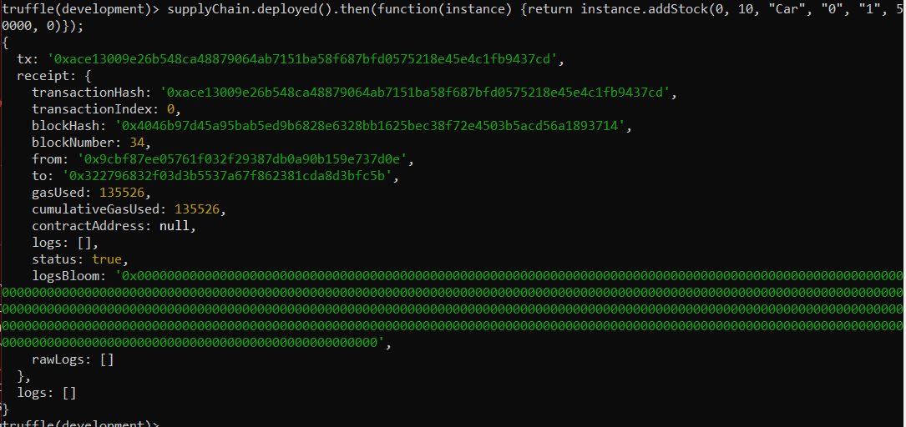

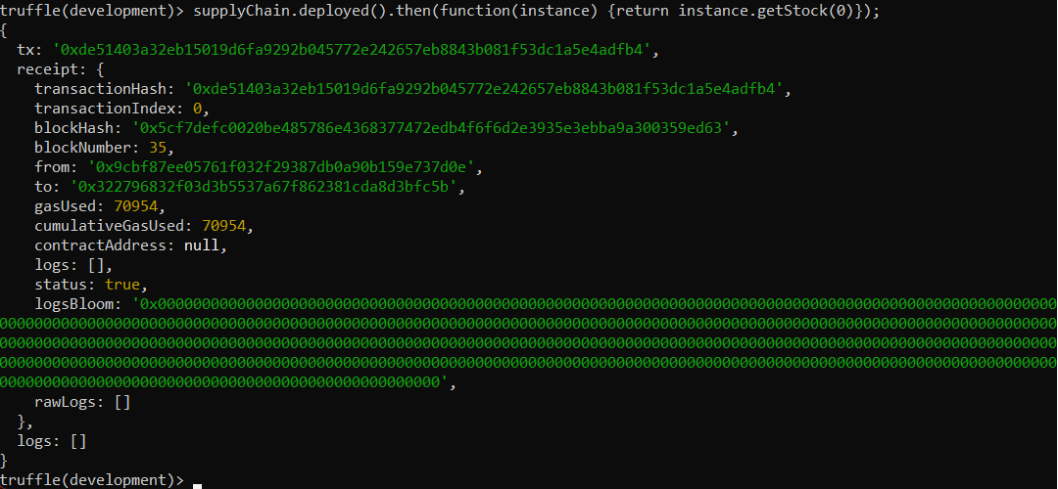



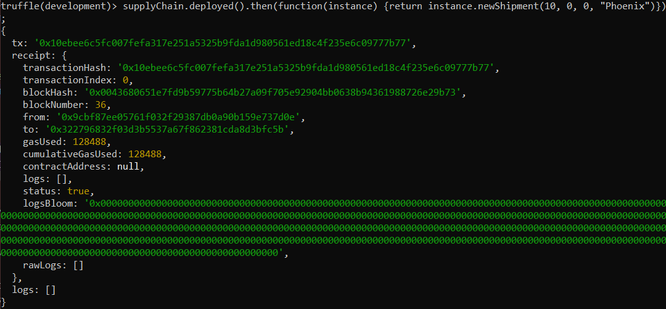

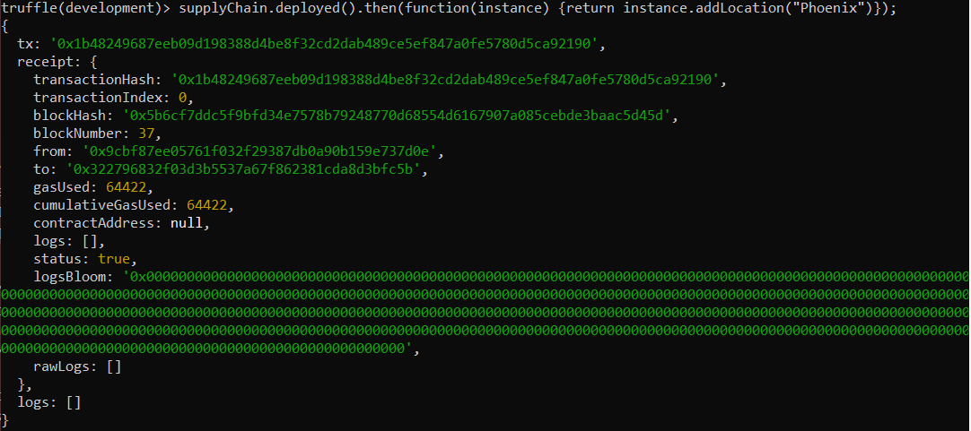



1. Loom Video

<https://www.loom.com/share/6758669dbd334e639ddd0d26675d6ee6>